MOSFET
Introduction
Historically, bipolar semiconductor devices (i.e, diode, transistor, thyristor, thyristor, GTO etc) have been the front runners in the quest for an ideal power electronic switch. Ever since the invention of the transistor, the development of solid-state switches with increased power handling capability has been of interest for expending the application of these devices. The BJT and the GTO thyristor have been developed over the past 30 years to serve the need of the power electronic industry. Their primary advantage over the thyristors have been the superior switching speed and the ability to interrupt the current without reversal of the device voltage. All bipolar devices, however, suffer from a common set of disadvantages, namely, (i) limited switching speed due to considerable redistribution of minority charge carriers associated with every switching operation; (ii) relatively large control power requirement which complicates the control circuit design. Besides, bipolar devices can not be paralleled easily. The reliance of the power electronics industry upon bipolar devices was challenged by the introduction of a new MOS gate controlled power device technology in the 1980s. The power MOS field effect transistor (MOSFET) evolved from the MOS integrated circuit technology. The new device promised extremely low input power levels and no inherent limitation to the switching speed. Thus, it opened up the possibility of increasing the operating frequency in power electronic systems resulting in reduction in size and weight. The initial claims of infinite current gain for the power MOSFET were, however, diluted by the need to design the gate drive circuit to account for the pulse currents required to charge and discharge the high input capacitance of these devices. At high frequency of operation the required gate drive power becomes substantial. MOSFETs also have comparatively higher on state resistance per unit area of the device cross section which increases with the blocking voltage rating of the device. Consequently, the use of MOSFET has been restricted to low voltage (less than about 500 volts) applications where the ON state resistance reaches acceptable values. Inherently fast switching speed of these devices can be effectively utilized to increase the switching frequency beyond several hundred kHz. From the point of view of the operating principle a MOSFET is a voltage controlled majority carrier device. As the name suggests, movement of majority carriers in a MOSFET is controlled by the voltage applied on the control electrode (called gate) which is insulated by a thin metal oxide layer from the bulk semiconductor body. The electric field produced by the gate voltage modulate the conductivity of the semiconductor material in the region between the main current carrying terminals called the Drain (D) and the Source (S). Power MOSFETs, just like their integrated circuit counterpart, can be of two types (i) depletion type and (ii) enhancement type. Both of these can be either n- channel type or p-channel type depending on the nature of the bulk semiconductor. The below Figure shows the circuit symbol of these four types of MOSFETs along with their drain current vs gate-source voltage characteristics (transfer characteristics).

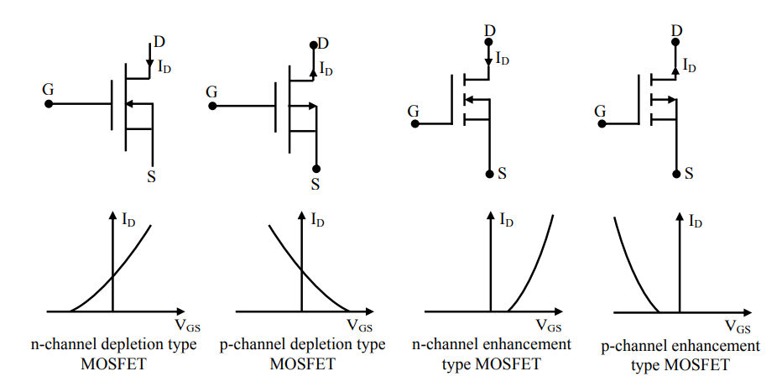

it can be concluded that depletion type MOSFETs are normally ON type switches i.e, with the gate terminal open a nonzero drain current can flow in these devices. This is not convenient in many power electronic applications. Therefore, the enhancement type MOSFETs (particularly of the n-channel variety) is more popular for power electronics applications.
Constructional Features of a Power MOSFET
As mentioned in the introduction section, Power MOSFET is a device that evolved from MOS integrated circuit technology. The first attempts to develop high voltage MOSFETs were by redesigning lateral MOSFET to increase their voltage blocking capacity. The resulting technology was called lateral double deffused MOS (DMOS). However it was soon realized that much larger breakdown voltage and current ratings could be achieved by resorting to a vertically oriented structure. Since then, vertical DMOS (VDMOS) structure has been adapted by virtually all manufacturers of Power MOSFET. A power MOSFET using VDMOS technology has vertically oriented three layer structure of alternating p type and n type semiconductors as shown in the above figure, which is the schematic representation of a single MOSFET cell structure. A large number of such cells are connected in parallel to form a complete device.
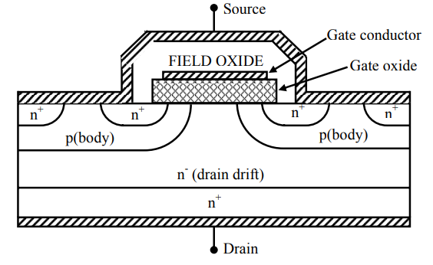
Construction of a single cell.

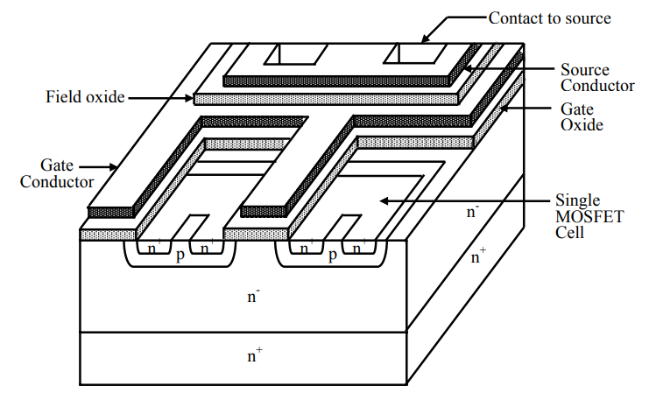

Arrangement of cells in a device

The two n+ end layers labeled “Source” and “Drain” are heavily doped to approximately the same level. The p type middle layer is termed the body (or substrate) and has moderate doping level (2 to 3 orders of magnitude lower than n+ regions on both sides). The n- drain drift region has the lowest doping density. Thickness of this region determines the breakdown voltage of the device. The gate terminal is placed over the n- and p type regions of the cell structure and is insulated from the semiconductor body be a thin layer of silicon dioxide (also called the gate oxide). The source and the drain region of all cells on a wafer are connected to the same metallic contacts to form the Source and the Drain terminals of the complete device. Similarly all gate terminals are also connected together. The source is constructed of many (thousands) small polygon shaped areas that are surrounded by the gate regions. The geometric shape of the source regions, to same extent, influences the ON state resistance of the MOSFET.

Operating principle of a MOSFET
At first glance it would appear that there is no path for any current to flow between the source and the drain terminals since at least one of the p n junctions (source – body and body-Drain) will be reverse biased for either polarity of the applied voltage between the source and the drain. There is no possibility of current injection from the gate terminal either since the gate oxide is a very good insulator. However, application of a positive voltage at the gate terminal with respect to the source will covert the silicon surface beneath the gate oxide into an n type layer or “channel”, thus connecting the Source to the Drain as explained next.
The gate region of a MOSFET which is composed of the gate metallization, the gate (silicon) oxide layer and the p-body silicon forms a high quality capacitor. When a small voltage is application to this capacitor structure with gate terminal positive with respect to the source (note that body and source are shorted) a depletion region forms at the interface between the SiO2 and the silicon as shown in figure (a).
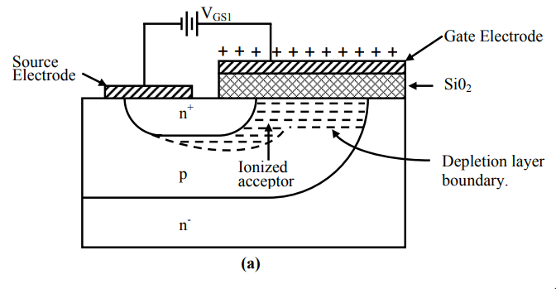
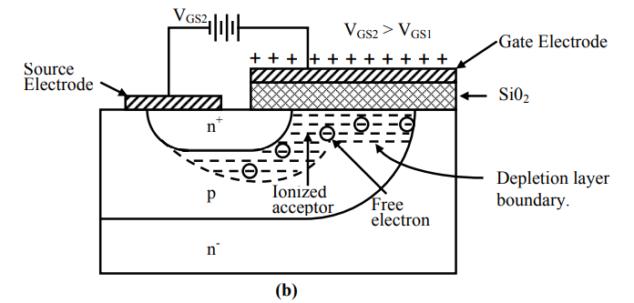
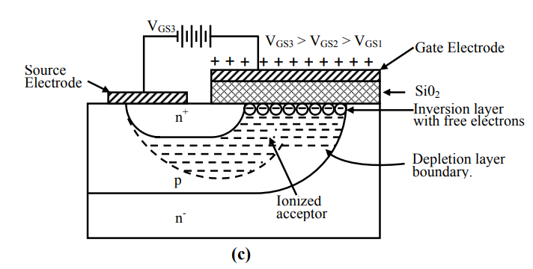
- Depletion layer formation; (b) Free electron accumulation; (c) Formation of inversion layer.
The positive charge induced on the gate metallization repels the majority hole carriers from the interface region between the gate oxide and the p type body. This exposes the negatively charged acceptors and a depletion region is created. Further increase in VGS causes the depletion layer to grow in thickness. At the same time the electric field at the oxide-silicon interface gets larger and begins to attract free electrons as shown in Fig 6.4 (b). The immediate source of electron is electron-hole generation by thermal ionization. The holes are repelled into the semiconductor bulk ahead of the depletion region. The extra holes are neutralized by electrons from the source. As VGS increases further the density of free electrons at the interface becomes equal to the free hole density in the bulk of the body region beyond the depletion layer. The layer of free electrons at the interface is called the inversion layer and is shown in Fig 6.4 (c). The inversion layer has all the properties of an n type semiconductor and is a conductive path or “channel” between the drain and the source which permits flow of current between the drain and the source. Since current conduction in this device takes place through an n- type “channel” created by the electric field due to gate source voltage it is called “Enhancement type n-channel MOSFET”. The value of VGS at which the inversion layer is considered to have formed is called the “Gate – Source threshold voltage VGS (th)”. As VGS is increased beyond VGS(th) the inversion layer gets some what thicker and more conductive, since the density of free electrons increases further with increase in VGS. The inversion layer screens the depletion layer adjacent to it from increasing VGS. The depletion layer thickness now remains constant.

